Lab 04:

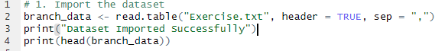
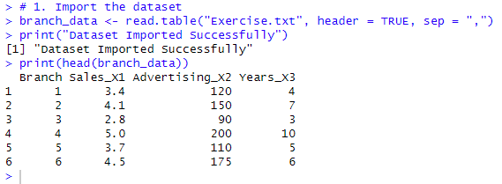

Variable Name | Variable Type | Scale Of Measurement
Banch_ID | Categorical | Nominal
Sales | Numerical | Ratio
Advertising | Numerical | Ratio
Years | Numerical | Ratio

